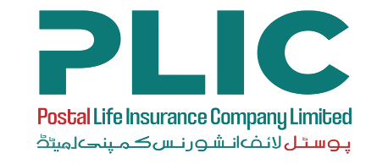;
POSTAL LIFE INSURANCE COMPANY LIMITED

(Wholly owned by Federal Government of Pakistan)

CAREER OPPORTUNITIES
Postal Life Insurance Company Limited (PLICL) is a key player in the life insurance business offering its services to the general public through a vast network all over Pakistan.

The Company is seeking to induct dynamic and result oriented professionals for the following positions:

S.No. | Position Title | No. of Posts | Max. Age | Minimum Qualification Requirement | Minimum Experience Requirement
01 | Regional Director (RD) (Karachi based) | 01 | 55 years | Graduation from HEC recognized university/ institute preferably in Marketing, Sales or any other related field. | 15 years of relevant experience of managing the overall insurance sales and support functions within the respective region within Life Insurance Sector out of which 5 years in a managerial position and leading sales team.

Candidates meeting the above criteria may apply online by selecting the position on our website at www.plic.com.pk/careers or email at career@plic.com.pk. Please mention position name in the email subject. Applications sent by post will not be accepted. The application must include the following:
- Resumé stating educational / professional qualifications, past and present experience and most recent salary drawn.

Last date of submission is May 30, 2022. Applications received after the expiry of the last date shall not be considered. PLICL reserves the right to shortlist, and or reject any or all applications against the above listed position.
Any candidate who directly or indirectly makes an attempt to influence the recruitment & selection process shall be disqualified.

Human Resources Department
WE ARE AN EQUAL OPPORTUNITY EMPLOYER. FEMALE CANDIDATES ARE ENCOURAGED TO APPLY.
Postal Life Insurance Company Limited
2nd floor, ECO Postal Staff College, Sector G-8/4, Islamabad
Ph: 051-9262814-15

